SUPERHUB WP4

SUPERHUB wp4-monitor development report

By Ignasi Gómez-Sebastià

SUPERHUB wp4-monitor development report

Content

Interface 1

Wp3 service integration 8

Situational Data service 9

Situational data Indicator template 11

Traffic situation service 26

Traffic situation Indicator template 26

# Interface

The monitor interfaces allows for starting the monitor, stopping it and retrieve sample series between two particular periods for a particular set of monitoring indicators.

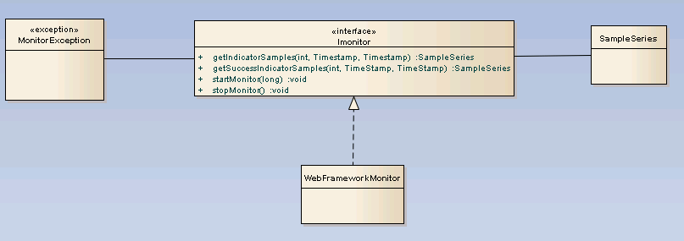

Figure 1 : Monitor interface

The Monitor interface consists of the following functions:

* getIndicatorSamples: For a particular indicator, the monitor component returns a time series element for the set of sample that happened after begin time and before end time. Comparison is performed via an open interval, therefore, samples happening exactly at the start or end intervals are included in the time series.
  + Throws a monitorException if parameter beginTime > parameter endTime
* getSuccessIndicatorSamples: For a particular success indicator, the monitor component returns a time series element for the set of sample that happened after begin time and before end time. Comparison is performed via an open interval, therefore, samples happening exactly at the start or end intervals are included in the time series. Please notice this functionality has not been implemented yet.
  + Throws a monitorException if parameter beginTime > parameter endTime
  + The instantiated success indicator must be included in a policy purpose
  + Is computed in base a succesIndicator instantation applying its parameters
    - Parameter values of the success indicator are passed to the corresponding indicators
  + Only the successIndicator’s formula is used. The score calculation formula is not used
  + The formula dependency points to the indicators used to compute the monitoring success indicators
    - The indicators used in the formula must be monitoring indicators
  + The successIndicatorID is searched among all available policy implementantions.
* startMonitor: Given a particular sampling period, the monitor starts computing sample series for all monitoring indicators. Samples are collected (*i.e.,* services are enacted) with a frequency determined by the sampling period provided as parameter. For every monitoring indicator, an instance of the *WP3DataClient* class is generated. The class contains the correct parameters to enact the particular service that will gather data for the monitor. The class enacts the service with a frequency determined by the sampling period provided as parameter, effectively recovering the service data required to compute the sample series values of the indicator.
  + Throws a monitorException if parameter samplingPeriod < 1000
* stopMonitor: The monitor stops computing samples for the monitoring indicators. This process will effectively stop the threads associated to the different instances of the *WP3DataClient* class, that have been enacting the WP3 services for gathering indicator data since the monitor was started.
  + Throws a monitorException if a non-running monitor is stopped (*e.g.*, stopping a monitor before starting it or trying to stop more than once).

Please, notice the class *IndicatorComputationTestCase* contains the function *ServiceTest* (associated to *IndicatorComputationTestCaseThread.run()*) that provides a functional example on how to use the monitor.

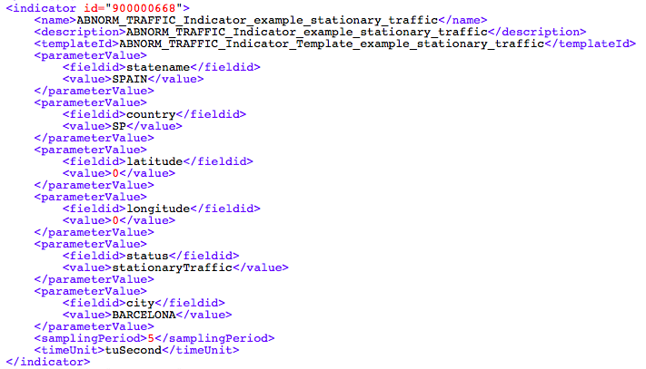

Figure 2: Monitoring indicator example

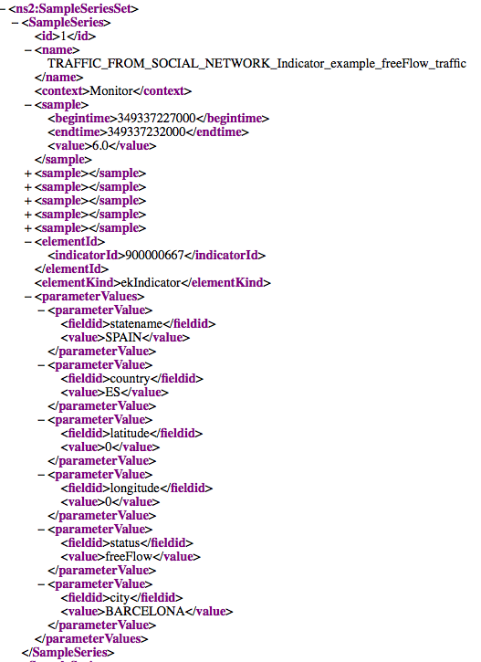

Figure 3: Indicator Sample series set example

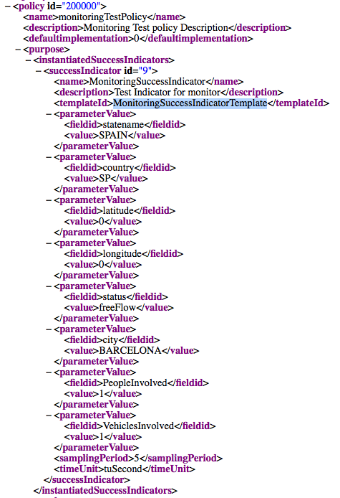

Figure 4 : Monitoring success indicator example

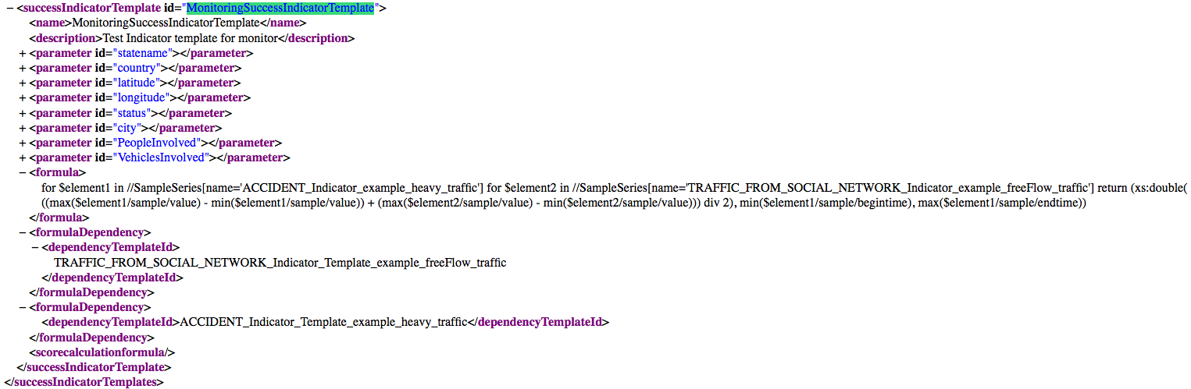

Figure 5 : Monitoring success indicator template instance

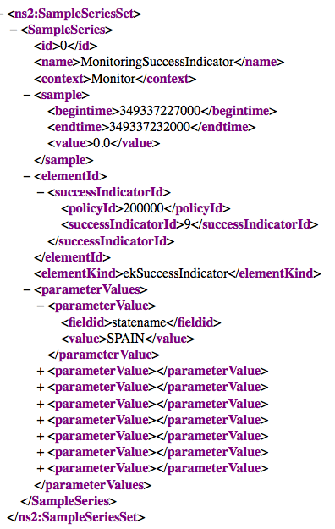

Figure 6 : Monitoring Success Indicator Sample Series instance

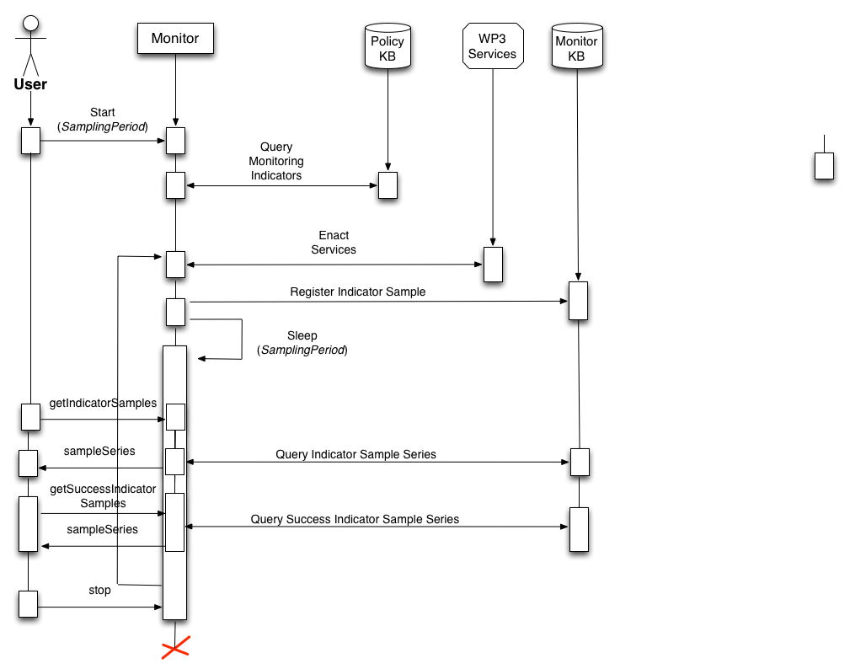

Figure 7 : Monitor execution flow

Wp4 Monitor Flow can be defined as follows:

1. The user starts the monitoring process with a particular sampling period.
2. The monitor queries the policy knowledge base retrieving all the available monitoring indicators. For each monitoring indicator available, a service enactment is performed. If the result of the enactment matches indicator’s parameters, an indicator sample is recorded. The monitor sleeps and repeats the process with a frequency equivalent to the sampling period.
3. When the user asks for indicator samples, the sample series in the monitor’s knowledge base are recovered. The samples are filtered and returned based on the user’s query (typically user will ask for sample between two particular periods).
4. When the user asks for success indicator samples, the monitor looks for the indicator samples the success indicator depends on. Of course, such indicators must be monitoring indicators. A sample series is dynamically built at runtime, and the query associated to the success indicator executed over these sample series. It results in a new sample series, whose results are filtered based on the user’s query.
5. When the user asks the monitor to stop, the process finishes. However, samples stored on the monitor’s KB remain for future use.

# Wp3 service integration

This section analysises monitor integration w.r.t. services in WP3 providing data to the monitor.

The integration of the monitor with the WP3 services is performed the *WP3DataClient* class.

There, the monitor is enacting the different WP3 services and pushing the results obtained to an event queue, where the service results are dealt with as if they were just monitoring events.

The *WP3DataClient* class is initialized in the *SituationalDataPusher* class. The *SituationalDataPusher* is initialized by the different classes testing the monitor (*e.g.,* the *PolicyIntegrationTestCase* class).

Therefore, in our approach, the parameters for the situational data services are stored in a class, containing the following information:

The class is initialized by the class starting the monitor (*e.g.,* test-case class, monitor interface...) and the situational data service parameters provided to the *SituationalDataPusher* class. There, the *SituationalDataPusher* class passes them to the *WP3DataClient* class that uses the parameters in the situational data services.

For backwards compatibility, the *SituationalDataPusher* class supports two interfaces, one where the situational data services parameters are provided and one where not. If the parameters are not provided the *SituationalDataPusher* class passes the *WP3DataClient* class a set of hard-coded testing service parameters. The set of hard-coded parameters is assigned by default in the *SituationalDataServiceParameters* class constructor.

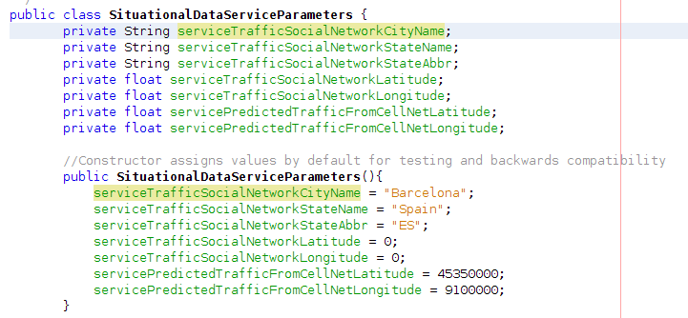

Figure 8 : *SituationalDataServiceParameters* class and its default values

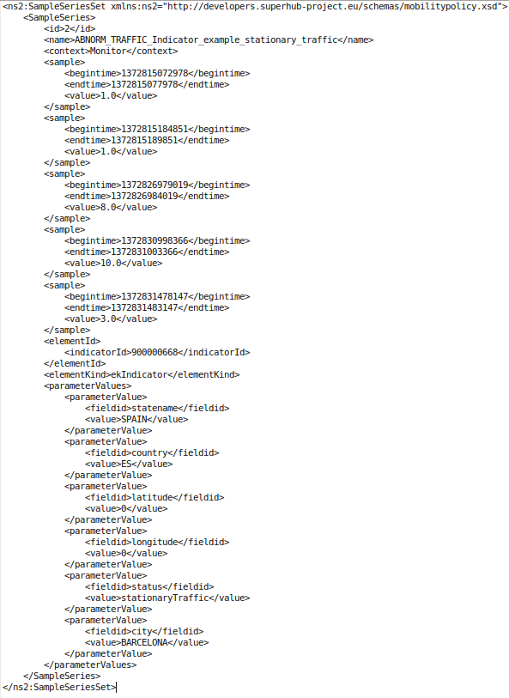

Figure 9 : Sample series generated by real service invocations from a sample mobility policy

## Situational Data service

Integration of the monitor with the situational data service is performed by injecting the statement, containing the information returned by the situational data service, in a statement queue.

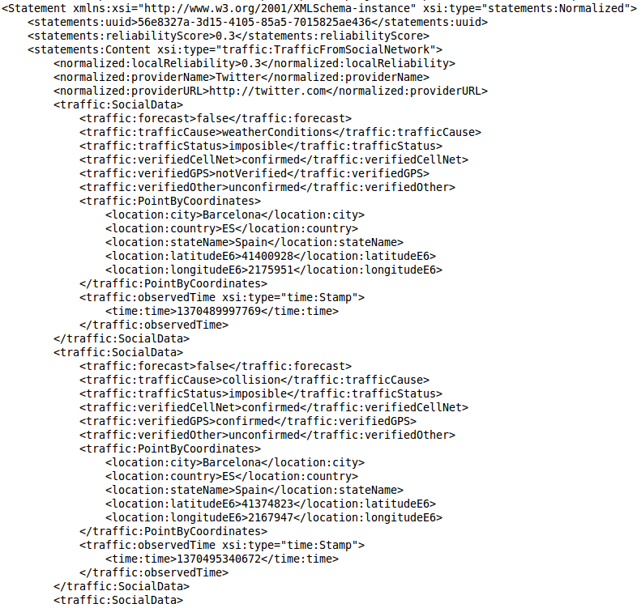

Figure 10 : Situational data example. Traffic from social network

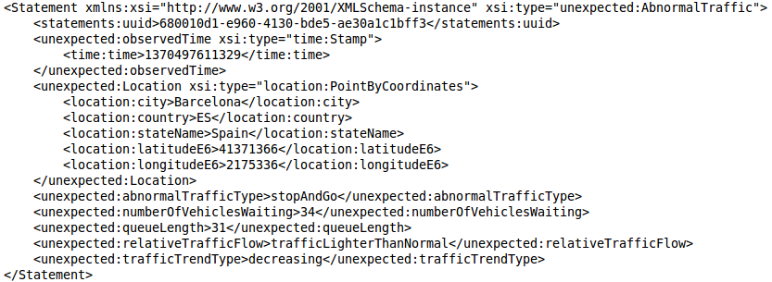

Figure 11 : Situational Data Service example. Abnormal Traffic

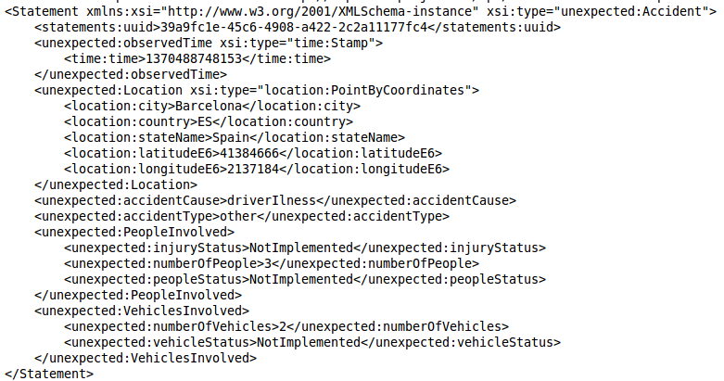

Figure 12 : Situational Data Service Example. Accident

### Situational data Indicator template

The TRAFFIC_FROM_SOCIAL_NETWORK indicator template contains the following information:

* City
* Country
* Statename
* Latitude
* Longitude
* Status
  + Impossible
  + Congested
  + Heavy
  + freeFlow
  + unknown

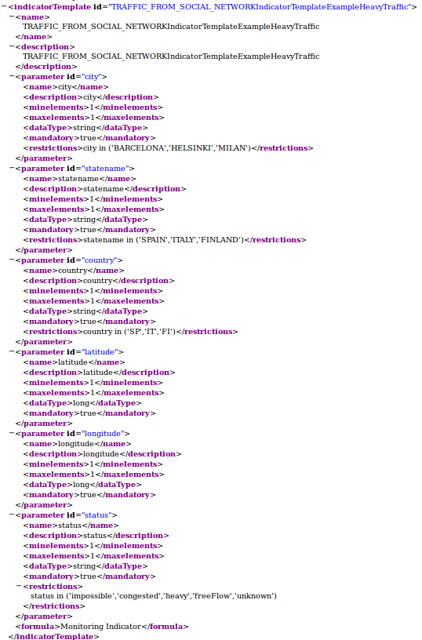

Figure 13 : Traffic From social network indicator template example 1

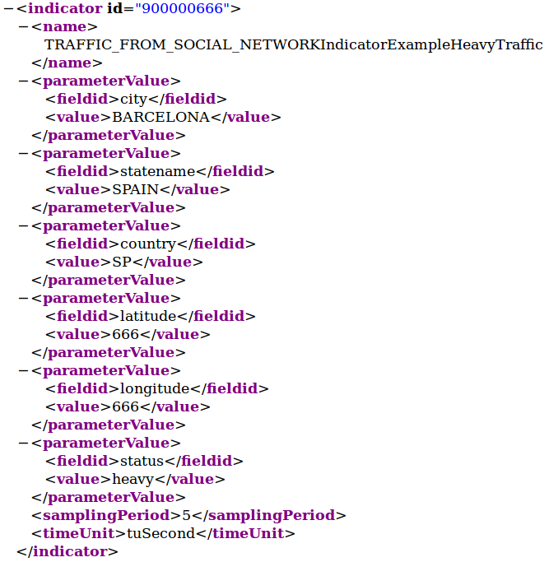

Figure 14 : Traffic from social network indicator example 1

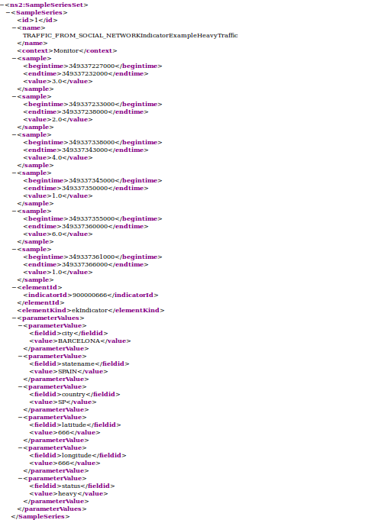

Figure 15 : Traffic from social networks indicator example time series

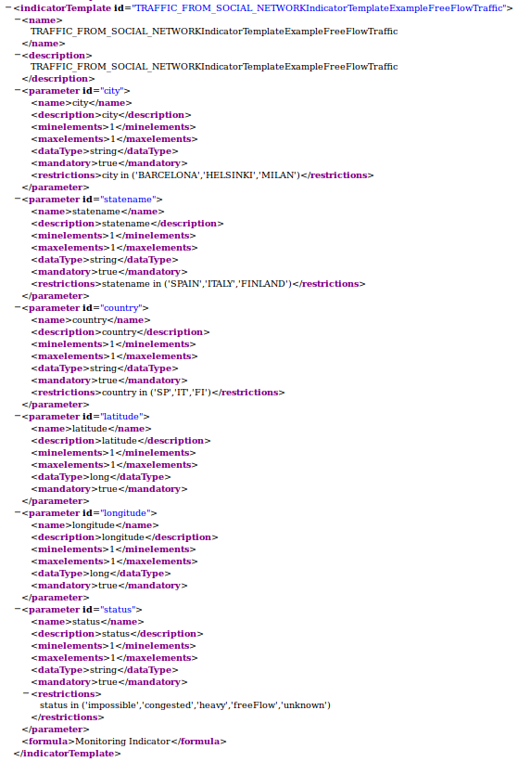

Figure 16 : Traffic from social network indicator template example 2

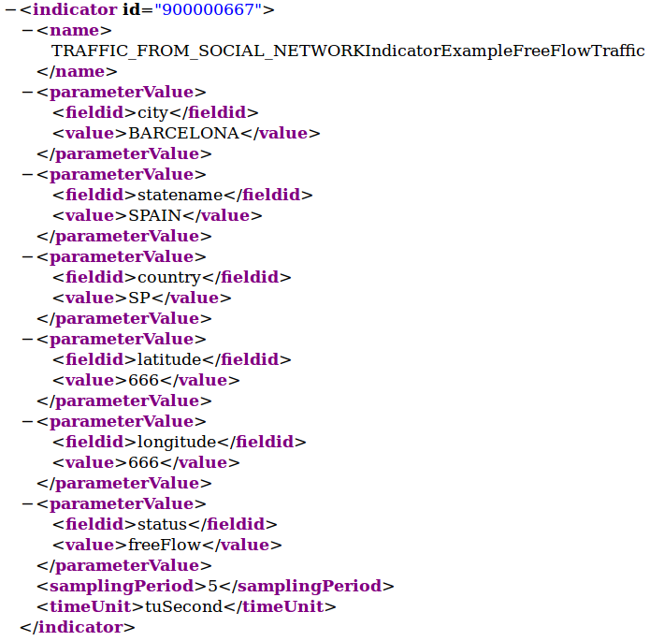

Figure 17 : Traffic from social network indicator example 2

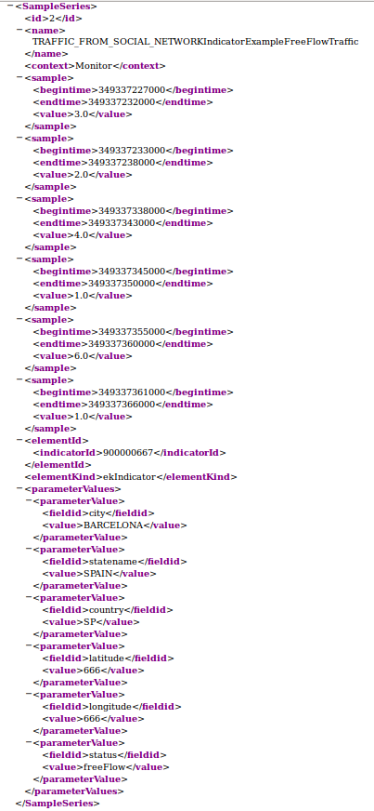

Figure 18 : Traffic from social networks sample series example 2

The ABNORMAL_TRAFFIC indicator template contains the following information:

* City
* Country
* Statename
* Latitude
* Longitude
* Status
  + queueingTraffic
  + stopAndGo
  + slowTraffic
  + stationaryTraffic

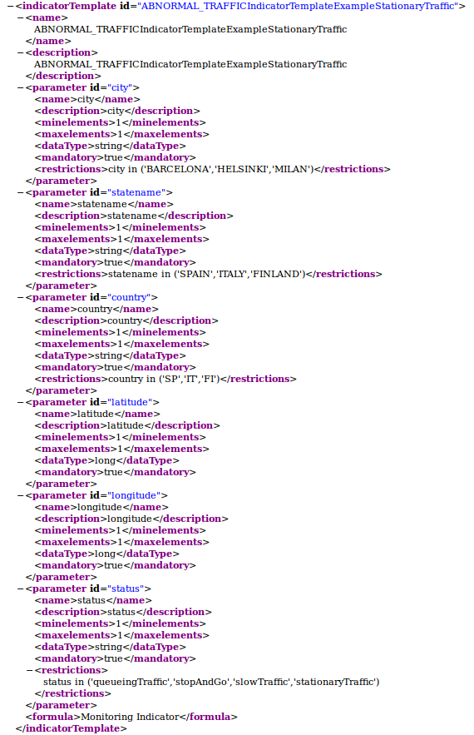

Figure 19: Abnormal traffic indictor template example

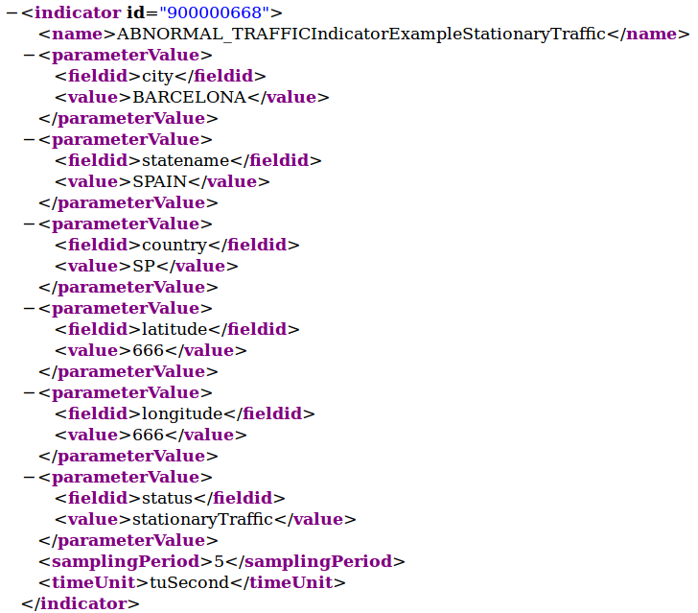

Figure 20 : Abnormal traffic indicator example

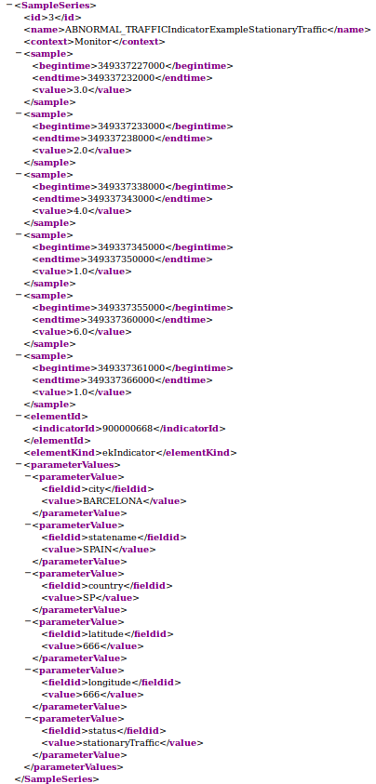

Figure 21 : Abnormal traffic sample series example

The ACCIDENT indicator template contains the following information:

* City
* Country
* Statename
* Latitude
* Longitude
* PeopleInvolved (Integer >= 0)
* VehiclesInvolved (Integer >= 0)

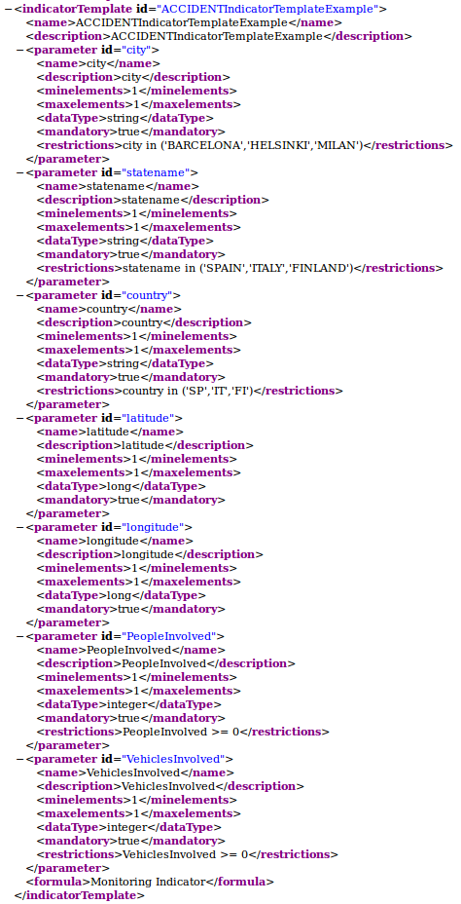

Figure 22 : Accident indicator template example

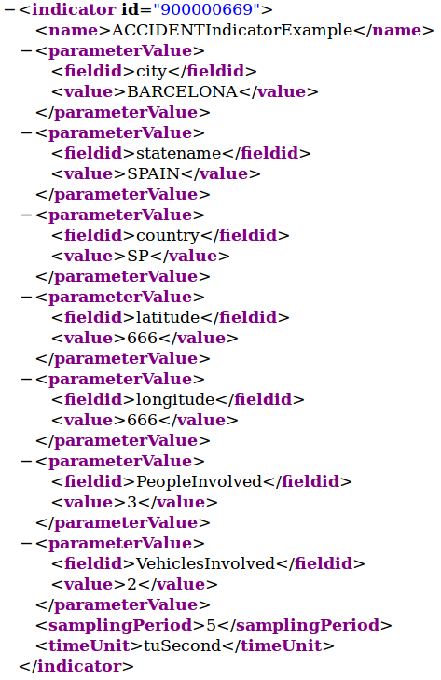

Figure 23 : Accident indicator example

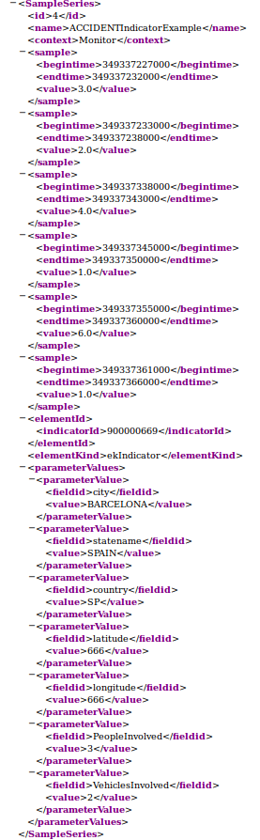

Figure 24 : Accident indicator time series example

## Traffic situation service

Integration of the monitor with the traffic situation service is performed by injecting in the *Statement queue* a *Raw Statement* containing the information returned by the traffic situation from cell net service, encoded as an XML String.

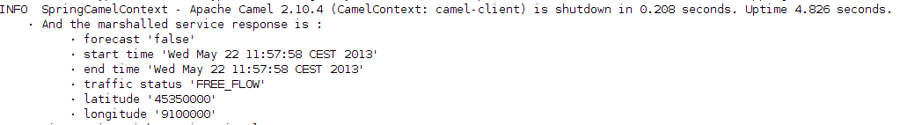

Figure 25: Traffic situation service example

### Traffic situation Indicator template

The traffic situation indicator template contains the following information:

* Longitude
* Latitude
* Status (From this step of values, other values don’t raise an error but will provide 0 indicators)
  + Impossible
  + Congested
  + Heavy
  + FreeFlow
  + Unknown

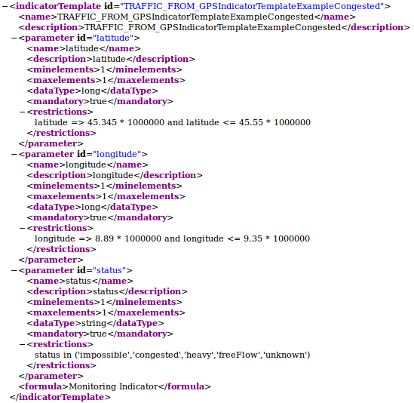

Figure 26 : Traffic from GPS indicator template example

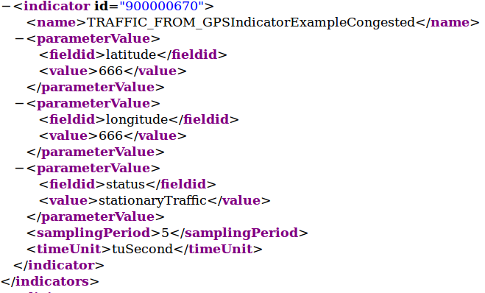

Figure 27 : Traffic situation indicator example

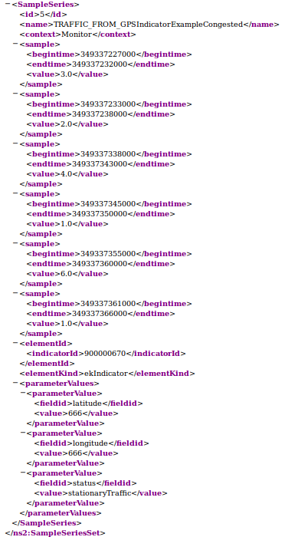

Figure 28 : Traffic situation sample series example